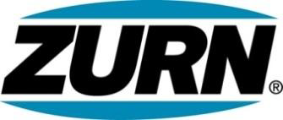

FOR IMMEDIATE RELEASE FOR MORE INFORMATION
DATE: February 3, 2015 Christine Verdecchia
Director of Communications
christine.verdecchia@zurn.com
814-875-1283

PHOTOS: www.lopressroom.com/zurn/WOC-2015

Zurn Showcasing Specification Drainage Products at World of Concrete
Booth # S11015

ERIE, PA – Zurn Industries, LLC is exhibiting its specifications drainage product line at the World of Concrete 2015 trade show in Las Vegas today through February 6.

Zurn engineers and manufactures a large breadth of drainage systems that feature a variety of materials and benefits. These include the Zurn Perma-Trench® drainage systems, the Zurn stainless steel linear drains, and the Zurn Z1900 series Stainless Steel Floor Sink Liner with a universal design that fits most floor sinks..

“Zurn specification drainage systems deliver reliable, durable and long-lasting performance for highways, airports, warehouses and other high-capacity installations throughout the country,” says Jeffrey Exley, Product Manager, Zurn Specification Drainage Group. “They are suitable for both new and retrofit projects.”

Editors and writers are encouraged to visit the Zurn booth (#S11015).

About Zurn Industries
Zurn Industries, LLC is a recognized leader in commercial, municipal, healthcare and industrial markets. Zurn offers the largest breadth of engineered water solutions, including a wide spectrum of sustainable plumbing products. Zurn delivers total building solutions for new construction and retrofit applications that enhance any building’s environment. For more information, visit www.zurn.com.

