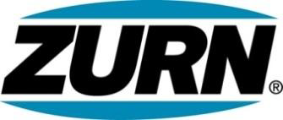

FOR IMMEDIATE RELEASE FOR MORE INFORMATION
DATE: December 15, 2015 Christine Verdecchia
Director of Communications
christine.verdecchia@zurn.com
814-875-1283

PHOTOS: www.lopressroom.com/zurn/unitedway2016

Zurn Raises $32,000 for United Way
Donations Target Local Communities

ERIE, PA – As part of its ongoing commitment to the communities where its employees live and work, Zurn Industries, LLC’s recent campaign for United Way raised $32,000.

Employees at all of Zurn’s offices and facilities across the country participated in the campaign, pledging to donate the money in 2016 through payroll deductions.

“The United Way invests in programs focused on education, income and health,” says Michele Meierhofer, Director of Marketing, Zurn. “Zurn appreciates the fact that United Way’s results are measurable and sustainable and, most importantly, all donations stay in the local community.”

Zurn associates have a long history of contributing to United Way.

About Zurn Industries
Zurn Industries, LLC is a recognized leader in commercial, municipal, healthcare and industrial markets. Zurn offers the largest breadth of engineered water solutions, including a wide spectrum of sustainable plumbing products. Zurn delivers total building solutions for new construction and retrofit applications that enhance any building’s environment. For more information, visit www.zurn.com.

# # #

