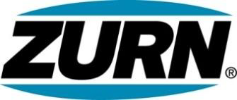

FOR IMMEDIATE RELEASE FOR MORE INFORMATION
DATE: April 29, 2015 Christine Verdecchia
Director of Communications
christine.verdecchia@zurn.com
814-875-1283

PHOTO: http://lopressroom.com/zurn/struts

Zurn Wilkins Small Backflow Preventers
Advance to Stainless Steel Struts

ERIE, PA – Zurn Industries, LLC introduces new stainless steel struts for its Zurn Wilkins 300 Small Backflow Preventers. The new models will be phased in April through June.

Customers experience the benefits of the enhancement at the start - with heavy gauge stainless steel struts weighing in lighter than existing forged bronze counterparts – especially the 2” 350 model – and throughout the product life cycle with corrosion resistance.

The shift from bronze to stainless steel also promotes theft deterrence.

Each of the new Zurn stainless steel backflow preventers – including the black fusion coated 375XLB model – will be stamped with the “XL” designation for easy identification as a lead-free product.

About Zurn Industries
Zurn Industries, LLC is a recognized leader in commercial, municipal, and industrial markets. Zurn manufactures the largest breadth of engineered water solutions in the industry, including a wide spectrum of sustainable plumbing products. Zurn delivers total building solutions for new construction and retrofit applications that enhance any building’s environment. For more information, visit www.zurn.com.
# # #

