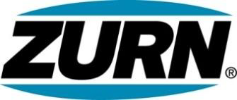

FOR IMMEDIATE RELEASE FOR MORE INFORMATION
DATE: September 3, 2015 Christine Verdecchia
Director of Communications and Brand
christine.verdecchia@zurn.com
814-875-1283

PHOTOS: www.lopressroom.com/zurn/relay

Zurn Associates Raise over $10,000 to help the American Cancer Society
Annual “Relay for Life” Events Combine Fundraising and Fun

ERIE, PA – Employees at three Zurn Industries, LLC locations raised $10,772 for the American Cancer Society’s Relay for Life local events.

In Erie, PA, workers began raising money through several events starting in April, crowning their efforts this summer with a combined 20-mile Relay for Life that carried the theme, “Celebrating More Birthdays.” A special lap was taken to honor Zurn’s own cancer survivors.

In Paso Robles, CA, the “Backflow in Motion” team took part in an onsite 24-hour Relay walk in June. Previously, the team also held other fundraising events for the American Cancer Society.

The Zurn team in Sanford, NC, hosted a number of Relay events, including the Themed Basket Drawing, a 12-hour Relay walk, and the Pie in the Manager’s Face event.

This is the fourth year that Zurn has raised money for the American Cancer Society.

About Zurn Industries
Zurn Industries, LLC is a recognized leader in commercial, municipal, healthcare and industrial markets. Zurn offers the largest breadth of engineered water solutions, including a wide spectrum of sustainable plumbing products. Zurn delivers total building solutions for new construction and retrofit applications that enhance any building’s environment. For more information, visit www.zurn.com.

# # #

