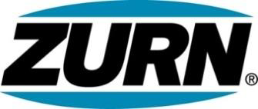

FOR IMMEDIATE RELEASE FOR MORE INFORMATION
DATE: December __ 2013 Christine Verdecchia
Director of Communications
christine.verdecchia@zurn.com
814-875-1283

PHOTO: www.lopressroom.com/zurn/food-drive-2013

Zurn Employees Hold Third Annual Food Drive

ERIE, PA – Local food banks in the United States and Canada will benefit this holiday season from a food drive held by employees of Zurn Industries, LLC.

Zurn employees raised an average of 13.27 pounds of non-perishable food per associate during a November initiative, with a company total of 8,905 pounds. In the case of monetary donations, each dollar was counted as one pound.

The participating Zurn locations included Erie, Pennsylvania; Sanford, North Carolina; Zurn Wilkins in Paso Robles, CA; Zurn PEX in Texas; Zurn Canada in Toronto; and the company’s Ontario, CA Service Center. Food banks local to these sites will receive the donations.

“This is the third year for this food drive,” says Miranda Schmidt, Sr. Marketing Specialist of Zurn, “and I can speak for everyone when I say charitable work benefits each of us as much as each recipient. We are proud that Zurn associates took the time to help those less fortunate than themselves.”

About Zurn Industries
Zurn Industries, LLC is a recognized leader in commercial, municipal, healthcare and industrial markets. Zurn manufactures the largest breadth of engineered water solutions in the industry, including a wide spectrum of sustainable plumbing products. Zurn delivers total building solutions for new construction and retrofit applications that enhance any building’s environment. For more information, visit www.zurn.com.

# # #

