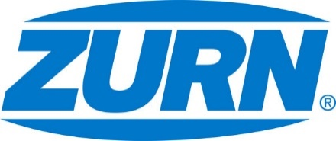

FOR IMMEDIATE RELEASE FOR MORE INFORMATION
DATE: January 16, 2018 Leslie McGowan
Marketing Communications
leslie.mcgowan@zurn.com
814-871-4757

PHOTOS: http://www.lopressroom.com/zurn/world-of-concrete

Zurn to bring top seller with added feature to World of Concrete
Leading drains exhibited at booth S11213
MILWAUKEE, WI – Zurn Industries, LLC will exhibit once again at the World of Concrete show in Las Vegas, January 23-26. World of Concrete is the largest conference and expo for construction and masonry professionals, boasting the most extensive range of jobsite manufacturers in one place. The event showcases over 1,500 leading suppliers, on top of providing hands-on and skill-building opportunities for attendees.

Zurn will be located at booth S11213 throughout the event. The manufacturer is dedicated to lean construction, ultimately solving for the contractor as much as the building owner. This year, Zurn will give attendees an in-person look at its enhanced Z886 Perma-Trench drain and its patented Z899 elevator/threshold drain.

“Every year we roll out our latest and greatest,” said Silvano Ferazzo, Product Manager. “This time around, we’re bringing our top-selling Z886 Perma-Trench to the booth. It’s not necessarily new, but we improved the contractor experience by adding a debris cover. The Z886 takes two workers to install, and now, they’ll know it’s protected from debris before a pour. This offering caps off a select drainage solution, saving labor and a step or two.”

“Jobsite problem solving doesn’t stop with our Perma-Trench,” added Jon Huddle, National Sales Manager. “Our new elevator and threshold drain is the only patented system on the market. The Z899 offers the ideal balance of lightweight design and durable stainless steel construction. It puts safety first without overlooking the contractor.”

World of Concrete covers over 170 education tracks, 80-plus sessions, and more than 140 industry speakers. The exhibit space will house over 55,000 registered industry professionals within 725,000 net square feet. Since inception in 1975, the conference has grown from 77 exhibiting companies to more than 1,500.

About Zurn Industries
Zurn Industries, LLC is a recognized leader in commercial, municipal, healthcare and industrial markets. Zurn offers the largest breadth of engineered water solutions, including a wide spectrum of sustainable plumbing products. Zurn delivers total building solutions for new construction and retrofit applications that enhance any building’s environment. For more information, visit Zurn.com.
# # #

