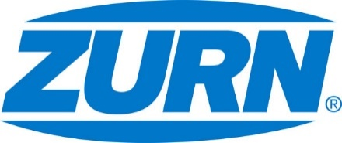

FOR IMMEDIATE RELEASE FOR MORE INFORMATION
DATE: December 19, 2017 Leslie McGowan
Marketing Communications
leslie.mcgowan@zurn.com
814-871-4757

PHOTOS: www.lopressroom.com/zurn/IBS-2018

Zurn to Exhibit at the NAHB International Builders’ Show
Located at Booth W6183
MILWAUKEE, WI – Zurn Industries, LLC announces its return exhibition at the NAHB International Builders’ Show in Orlando, Florida, January 9-11. IBS is the world’s largest conference and expo for light construction, attracting 60,000 visitors from 100 countries. The event showcases more than 1,400 top manufacturers and suppliers, bringing the most innovative and in-demand products to one space.

Zurn will be located at booth W6183 throughout the event. While all of the exhibitors focus on construction solutions, the manufacturer zeroes in on water control, safety, and conservation through a wide product offering. This year, Zurn will give attendees an in-person look at its newly expanded PEX line.

“2017 was a year of rollouts for Zurn, namely our ASTM F1960 expansion fittings and accessories," said Patrick Sauer, Director of Residential Plumbing. "Our new Expansion PEX System completes the complementary Zurn line and works with the same PEX pipe as our insert and crimp system. Meaning, no matter which plumbing professionals prefer – crimp or expansion – they can complete their solution with the industry’s leading pipe in UV and chlorine resistance. We look forward to showing this new system and the pipe’s flexibility and strength at the show.”

The event will feature hundreds of educational sessions. Registration is open until the last day of the show with accrued pricing. Members and non-members can participate for the full duration or one day.

About Zurn Industries
Zurn Industries, LLC is a recognized leader in commercial, municipal, healthcare and industrial markets. Zurn offers the largest breadth of engineered water solutions, including a wide spectrum of sustainable plumbing products. Zurn delivers total building solutions for new construction and retrofit applications that enhance any building’s environment. For more information, visit Zurn.com.
# # #

