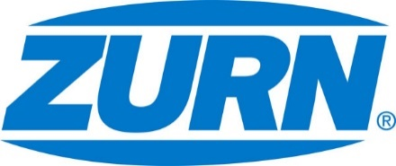

FOR IMMEDIATE RELEASE FOR MORE INFORMATION
DATE: October 26, 2017 Leslie McGowan
Marketing Communications
leslie.mcgowan@zurn.com
814-871-4757

PHOTOS: www.lopressroom.com/zurn/greenbuild-2017

Zurn to Unveil Latest Water Saving Solution at Greenbuild Expo
Showcased at booth #818

MILWAUKEE, WI – Zurn Industries, LLC announces its return exhibition at the Greenbuild International Conference and Expo in Boston, Massachusetts, Nov. 8-10. Greenbuild is the world’s largest conference & expo for the U.S. Green Building Council. The premier event unites professionals dedicated to sustainable building in their everyday work, from non-profit organizations to global firms.

Zurn will be located at booth #818 during the conference. While all of the exhibitors focus on greener building construction and solutions, the manufacturer zeroes in on water safety and sustainability. This year, Zurn plans to offer design experts, architects, and building owners an in-person look at its low-flow, modern concept Sundara™ Handwashing System.

“Water is our most precious resource – it is vital to so many aspects of daily life,” said Joel Marmion, Zurn Product Manager. “A lot of consideration goes into our solutions to make sure they use less water without compromising power and performance. Sundara takes it a step further with its unparalleled beauty. We can’t wait to bring it to the forefront at Greenbuild – to share it with professionals who care about the environment and aesthetics.”

Sundara was launched earlier this year. The design involved 10,000 research hours, 150 architect interviews and 26 prototypes. It is one of the first handwashing systems that focuses on both form and function to elevate the commercial restroom experience.

About Zurn Industries
Zurn Industries, LLC is a recognized leader in commercial, municipal, healthcare and industrial markets. Zurn offers the largest breadth of engineered water solutions, including a wide spectrum of sustainable plumbing products. Zurn delivers total building solutions for new construction and retrofit applications that enhance any building’s environment. For more information, visit Zurn.com.
# # #

